**Tools - Setup**

* **Purpose**

**1 Check the board is booting and connect an hyper terminal**

**2 How to copy from Linux PC host to board target**

**2.1 With usb key**

**2.2 Board as usb mass storage of PC**

**2.3 copy via Ethernet over USB connection**

**3 How to install AC6 system workbench on Linux PC host**

**3.1 Install system workbench**

**3.2 Install CoprocMPU eclipse plug-in**

**4 How to install STM32CubeMx on Linux PC host**

|  |
| --- |
| ***Color convention : in pink rectangle for command on the board*** |

|  |
| --- |
| ***Color convention : in blue rectangle for command on Linux Host*** |

**1 Boot the board and connect an hyper terminal**

**All info about the board is there**

**(there is no user guide document as we have in the MCUs)**

<http://intranet.lme.st.com:8000/php-bin/ug_mcdmpu/index.php/STM32MP157X-DKX_-_hardware_description>

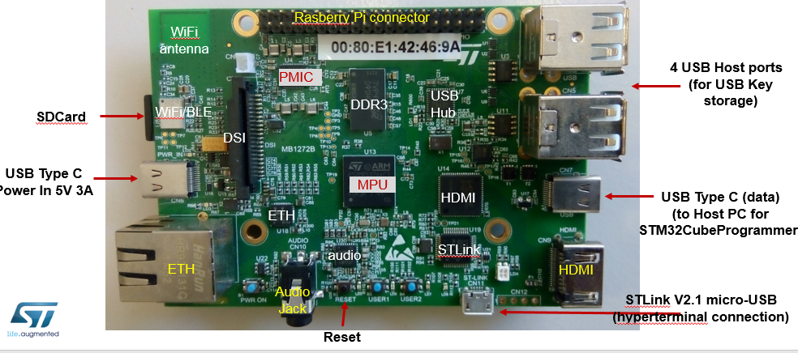

**USB OTG port to HOST PC**

**For CubeProgrammer**

**For usb over Ethernet**

**For Uboot in mass storage**

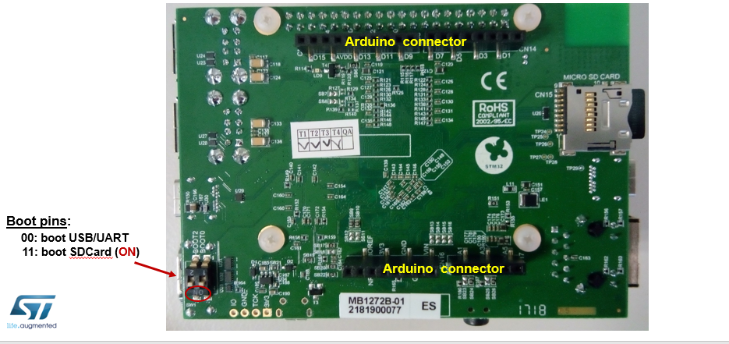

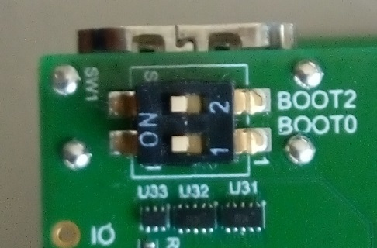

**Boot on SDcard (11)**

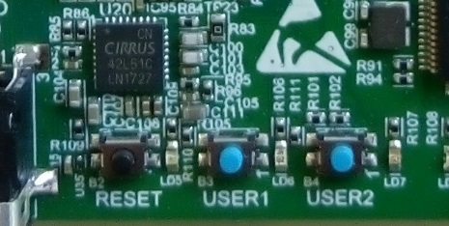

**Purpose: Interact with Discovery from a Linux Host hyper terminal window.**

**You can execute on target some linux commands you have entered into the hyper terminal window**

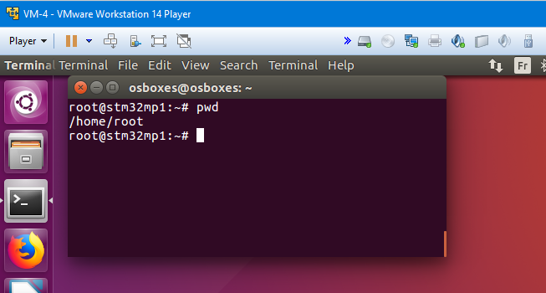

Check connections with ST-Link

* 1. Ensure your SDCard is plugged
  2. Connect the Linux host PC to the ST-LINK-v2 port of the discovery (Micro-USB cable)
  3. Power-On the discovery with USB (USB C cable - power supply)

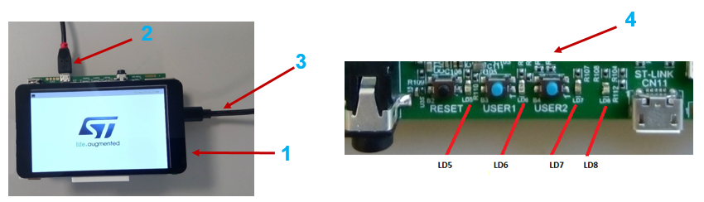

* 1. Install **on your Linux host PC** the hyper terminal application called “minicom”

|  |
| --- |
| ***apt-get install minicom*** |

* 1. Enable the ST-Link USB connection to the Linux virtual machine

You should see the ST-Link usb connection on the list, select connect

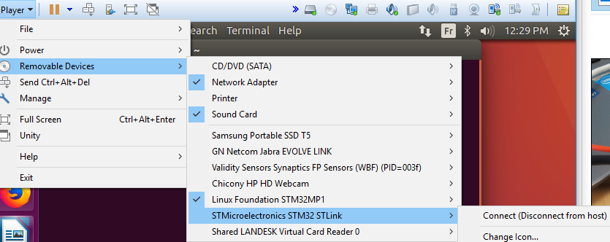

* 1. Launch Hyper terminal **on your Linux PC** . The Uart is connection between the Linux PC and the discovery is done via the ST-LINK cable (2)

|  |
| --- |
| **minicom -D /dev/ttyACM0** |

Default UART settings are OK , **no need to change.**

Baud rate 115200

Data 8bit

Parity none

Stop 1bit

Flow control none

* 1. **Reset the board with black reset button**,

then observe the log **in the Hyper Terminal window on** **your Linux PC host** :

Machine generated alternative text:
INFO: 
INFO: 
INFO: 
INFO: 
INFO: 
INFO: 
INFO: 
Boot used partition f s h 11 
BL2: Loading image 
Loading image id24 
Inage idz4 loaded: 
BL2: Loading image 
Loading image id—5 
GPT partition size 
id 4 
at address Øx2ffe3ØØØ 
Øx2ffe3ØØØ - Øx2fff6ØØØ 
at address øxcmøøøøø 
: 663552 
WRRNING: Skip signature check (header option) 
INFO: 
Inage id-5 loaded: øxcøl øøøøø - ØxcØ1a2ØØØ 
etyxevxng e: / u mage 
38"2896 bytes read in 519 aø.7 
nppend: root rootwait ru earlyprintk console—ttyS3.1152ØØ 
Retrieving f ile: /stn32npIS7c—euI -dtb 
'2761 b tec read in 14 (4.3 Hi B/c) 
Starting kernel 

The board is booted when you get the linux prompt

C:\316D4E85\219883C3-A730-4C19-A553-FC4421375923_files\image002.png

**2 How to copy from Linux PC host to board target**

**We present 3 different methods to copy files to the target.**

**2.1 Copy to board using a USB key**

**Purpose:**

**you have a file on your USB Key (an JPEG image for ex) and you want to copy it on the target.**

Insert usb key in board

Observe logs as follows

Machine generated alternative text:
Otestn32mp1:z• 
65.3114391 ed tgdal 
64.1aøB38J 
usb 2-1.4- 
b-stora 2-1.4:1.ø: USB 
2-1 .ø 
new 
s device 
san Disk 
logical 
is off 
USB 
de u ice 
detected 
3 using 
1.26 PO: ø ANSI: S 
64.2572161 
64.2631161 
6s.2?1348J 
65.29488" 
6s.3ø617S1 
gdal 
Write 
cache: 
SCSI 
disabled. read cache: enabled. doesn't support DPO or 
dick 

With the *mount* command USB key content is then visible under /mnt

|  |
| --- |
| ***mount –t vfat /dev/sda1 /mnt -v*** |

To see the content:

|  |
| --- |
| ***ls /mnt*** |

example of copy (need to use sync command to force the copy)

|  |
| --- |
| **cp /mnt/<filename> /home/root**  **cp –a /mnt/<directory\_name> /home/root** |
| **sync** |

**Step 2.2 : Copy to board seen as mass storage for Linux Host**

**(Linux host is connected to USB OTG board port)**

**Purpose:**

**you have a file on your Linux host (a binary just compiled for ex)**

**and you want to copy it on the target.**

<http://intranet.lme.st.com:8000/php-bin/ug_mcdmpu/index.php/How_to_use_USB_mass_storage_in_U-Boot>

* + USB Plug cable on the USB OTG port
  + To enter in uboot shell : **press Reset button** on the target and during boot time **Press any key** in hyper terminal window in Linux host
  + On target in uboot prompt launch

|  |
| --- |
| **ums 0 mmc 0** |

(The HyperTerminal is blocked)

On linux host rootfs and bootfs partition are available in /media/<user>/bootfs where "<user>" is the user account.

In case rootfs or bootfs are not mounted from linux, click on launcher bar (new usb folder icons)

On Linux host open a new console call the following commands to copy in target “**/”** directory

|  |
| --- |
| **cp {path on linux host}/your file /media/user/home/rootfs**  then unmount usb drive |

For example to copy stm32\_usbo\_eth\_config\_new.sh from your Linux host desktop

into your target home directory (~ or /home/root)

|  |
| --- |
| **cp /home/Desktop/stm32\_usbo\_eth\_config.sh /media/<user>/rootfs/home/root/**    **then unmount usb drive** |

**2.3 Copy via Ethernet over USB connection**

**(Linux host is connected to USB OTG board port)**

**Purpose:**

**You have a file on your Linux host (a binary just compiled for ex)**

**and you want to copy it on the target.**

**We make an Ethernet connection using the USB OTG cable (to avoids the Ethernet cable and router)**

**We use the linux USB Ethernet gadget.**

**2.3.1 Discover your environment (only once)**

* + **Connection**

**connect the USB OTG type C cable to the PC**

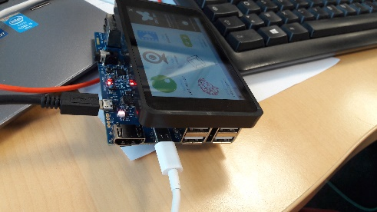

USB OTG port is the white cable

* + **Observe the name of the Ethernet over USB i/f on Linux host** **of the USB OTG cable**

**Get the** **name** of the Ethernet over USB i/f on Linux Host of the USB OTG cable

**On host, observe the list all the Ethernet i/f:**

|  |
| --- |
| **ifconfig** |

**seek for the name of i/f that correspond to**  Ethernet USB i/f

here we see : " **ens35u1** Link encap:Ethernet HWaddr 7e:cd:ed:45:72:72

UP BROADCAST RUNNING MULTICAST MTU:1500 Metric:1"

**To identify the name**, disconnect the USB OTG cable

Re-type ifconfig, the name of the I/F **disappears** in the list given by ‘ifconfig’.

* **On target, the IP address is 192.168.7.2 assigned by default**

On the target in the hyper terminal window

in **/home/root** (or **~**) directory

|  |
| --- |
| **Ifconfig** |

**when the OTG cable (typeC) is connected**

we see

"**usb0** Link encap:Ethernet HWaddr ….

inet addr:**192.168.7.2** Bcast:

**2.3.2 Configure Linux host Ethernet over USB i/f**

Once you know the **name** of Linux host Ethernet over USB i/f of the USB OTG cable.

**Connect the USB OTG cable**

If Linux host starts a DHCP address search, network top right **icon** there show a "searching pictogram"

Machine generated alternative text:


* 1. **Click on top right network icon and click on "Disconnect" of the "Wired connection2"**

Machine generated alternative text:
Ethernet Network ()
Wired connection 2
Disconnect

=> A Ubuntu Pop-up "Disconnected" should happen; Then the network icon show vertical arrows

Machine generated alternative text:
ti, m 4))) 10:44 

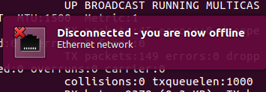

* 1. **Assign 192.168.7.1 address to Linux host Ethernet USB i/f**

**Before you know, the name of your Linux host Ethernet USB i/f (see above)**

**here it is : “ens35u1”**

**Assign to this i/f the 192.168.7.1 address with the command :**

|  |
| --- |
| **sudo ifconfig ens35u1 192.168.7.1 netmask 255.255.255.0** |

To check the Linux Host :

|  |
| --- |
| **Ifconfig ens35u1**  (If not up  **sudo ifup ens35u1)** |

you should see :"**ens35u1** Link encap:Ethernet HWaddr 4a:83:81:8b:a1:3b

inet addr:**192.168.7.1** Bcast:192.168.7.255 Mask:255.255.255.0

inet6 addr: fe80::4883:81ff:fe8b:a13b/64 Scope:Link

**UP** BROADCAST RUNNING MULTICAST MTU:1500 Metric:1

…."

If the connection is shut-down in VMWare

=> reassign the Ip :

|  |
| --- |
| **sudo ifconfig ens35u1 192.168.7.1 netmask 255.255.255.0** |

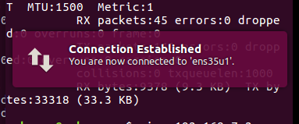

**2.3.3 Check Ethernet over USB connection**

* 1. **Check connection :**

192.168.7.2 (address of the target)

192.168.7.1 (address of the Linux host)

On Linux Host

|  |
| --- |
| **ping 192.168.7.2** |
|  |

On board

|  |
| --- |
| **ping 192.168.7.1** |

* + 1. **Configure Linux host Ethernet over USB i/f permanently**

If the connection name is always the same after each cable connection,

You can setup permanently the connection as follows

1. Assign an IP address to Linux host (**192.168.7.1**) to your Ethernet USB i/f **name** (here "**ens35u1** “)

In Linux host edit as follow

|  |
| --- |
| **sudo gedit /etc/network/interfaces &** |

Add the Ethernet i/f name you have (here ens32u1)

# Ethernet/RNDIS gadget (g\_ether)

allow-hotplug **ens35u1**

iface ens35u1 inet static

address 192.168.7.1

netmask 255.255.255.0

network 192.168.7.0

gateway 192.168.7.1

1. Disable the **networkManager** for the all the Ethernet USB i/f starting by **ens35**\* (=name of your i/f)

-Otherwise it searchs for DHCP IP address during 30s then any IP previously assigned to the I/f is lost

1. In linux host edit as follow :

|  |
| --- |
| **sudo gedit /etc/NetworkManager/conf.d/stm32mp-otg-eth.conf &** |

Add in file

[keyfile]

unmanaged-devices=interface-name:**ens35**\*;interface-name:usb\*

1. Reboot the Linux Host
   * 1. **Copy via Ethernet over USB**

Once the Ethernet Over USB link is well configured and up,

you can use the **scp** command to make copies between the target and the Linux host machine.

|  |
| --- |
| scp -r {path}/\* root@<ip address>:/ |

On target, force the file system to update the copy into the sdcard

by

|  |
| --- |
| **Sync** |

For example,

If you have a folder on *Linux host machine* under /opt/tm32mp1-3day/01 STM32MP1\_Getstarted

that you want to **copy** on the *target* root directory “/”

make the command on Linux Host:

|  |
| --- |
| scp -r **/opt/tm32mp1-3day/01 STM32MP1\_Getstarted/** root@**192.168.7.2**:/ |

|  |
| --- |
| **Sync** |

**3 Installation of STM32Cube\_MPU Package**

<https://wiki.st.com/stm32mpu/index.php/STM32-CoPro-MPU_plugin_release_note>

* + **Installation of SystemWorkbench 2.8.0 + STM32-CoPro-MPUMicroprocessor Unit plugin version 1.0.0**

***Package with eclipse Neon + st-link + st openOCD + Coproc plug-in***

1. Ensure SystemWorkbench 2.6 is not already installed on your Linux host

Otherwise in folder where eclipse binary is stored run : java -jar uninstall.jar

1. Download SystemWorkbench 2.8 installer for Linux 64 bits

<https://wiki.st.com/stm32mpu/index.php/STM32-CoPro-MPU_plugin_release_note>

you need to be logged in the wiki to see internal repository

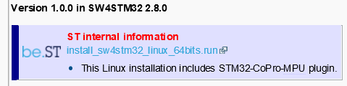

Or for customers

* + - Register or login [www.openstm23.org](http://www.openstm23.org)
    - From page

<http://www.openstm32.org/Downloading%2Bthe%2BSystem%2BWorkbench%2Bfor%2BSTM32%2Binstaller>

copy on Linux host ~  **install\_sw4stm32\_linux\_64bits-v2.8.run**

1. Open Terminal

cd ~/Desktop

./install\_sw4stm32\_linux\_64bits-v2.8.run (in manual mode, answer yes to all questions)

1. Run click on "SystemWorkbench for STM32" icon on Desktop   
   or /Ac6/SystemWorkbench/eclipse&

The first time Systemworkbench is started , the gcc tool chain is installed.

To check release install :

eclipse menu “Help” -> “installation details” search for

" OpenSTM32IDE        **2.8.0. …..**        fr.ac6.feature.mcu.ide.feature.group        Ac6"

Check release install : Help / "installation details" menu search for

“STM32-CoPro-MPU - Cortex-M debug support on Hybrid architecture SoC  
        **1.0.0. …..**        com.st.stm32ide.mpu.feature.debug.feature.group        STMicroelectronics”

**4 Installation of STM32CubeMX**

<https://wiki.st.com/stm32mpu/index.php/STM32CubeMX>

Get CubeMx version from

<https://www.st.com/en/development-tools/stm32cubemx.html>

|  |
| --- |
| **mkdir  ~/STM32MPU-Tools** |

|  |
| --- |
| **cd ~/STM32MPU-Tools/SetupSTM32CubeMX-xxx**  **Unzip SetupSTM32CubeMX-xxx.zip** |

Open in web browser ~/STM32MPU-Tools/SetupSTM32CubeMX-xxx/Readme.html

Check Install Java JRE 1.7.0\_45 or a more recent version:

|  |
| --- |
| **sudo apt-get install default-jre**  **./SetupSTM32CubeMX-xxx.linux** |

Launch:

|  |  |
| --- | --- |
| **~/STM32CubeMX/STM32CubeMX &** |  |